**INSTALLATION OF PYTHON 3.9.8**

|  |  |
| --- | --- |
| **TEAM ID** | PNT2022TMID29999 |
| **PROJECT NAME** | GAS LEAKAGE MONITORING AND ALERTING SYSTEM FOR INDUSTRIES |

Step 1: Type python in google and click on the first link

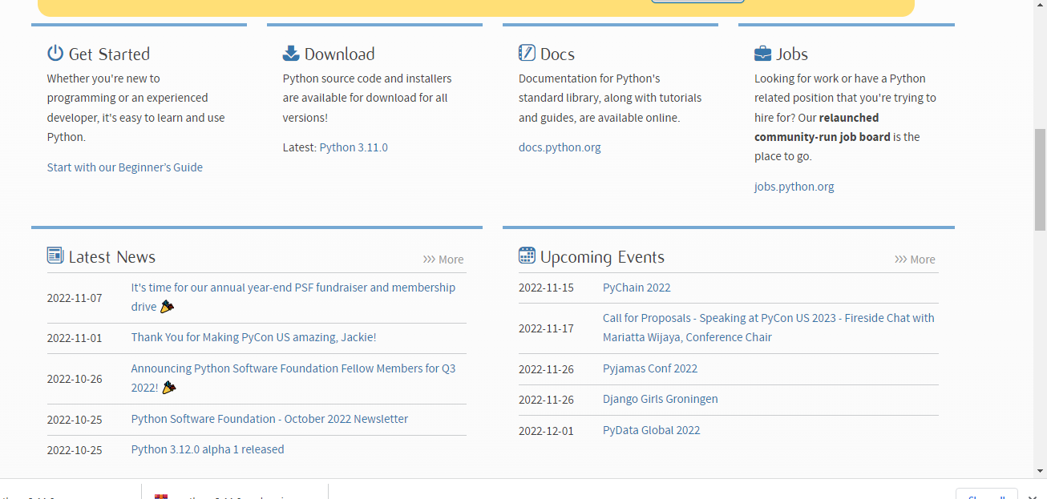

Step 2:

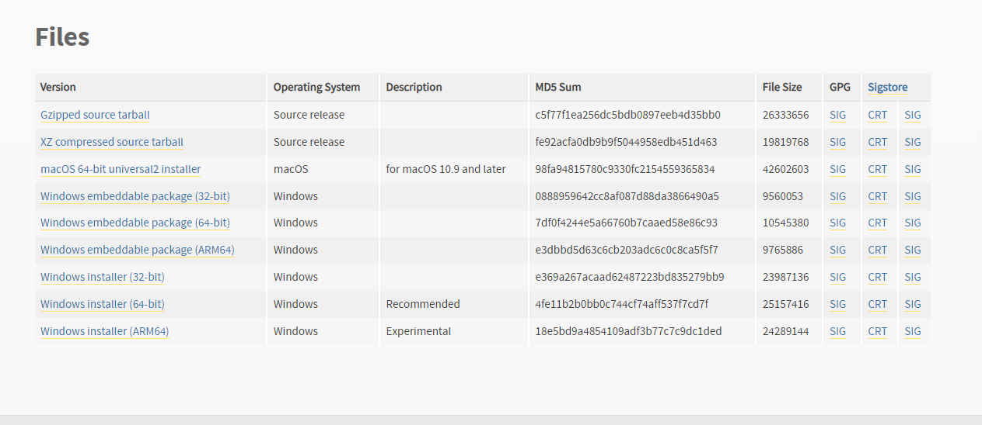

Step 3:

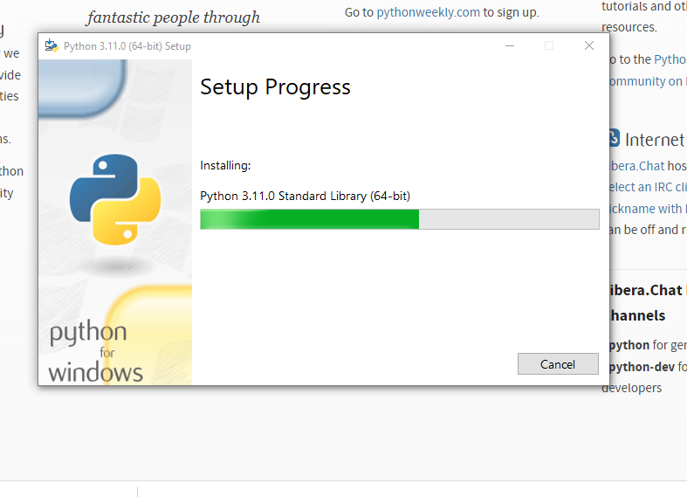

Step 4:

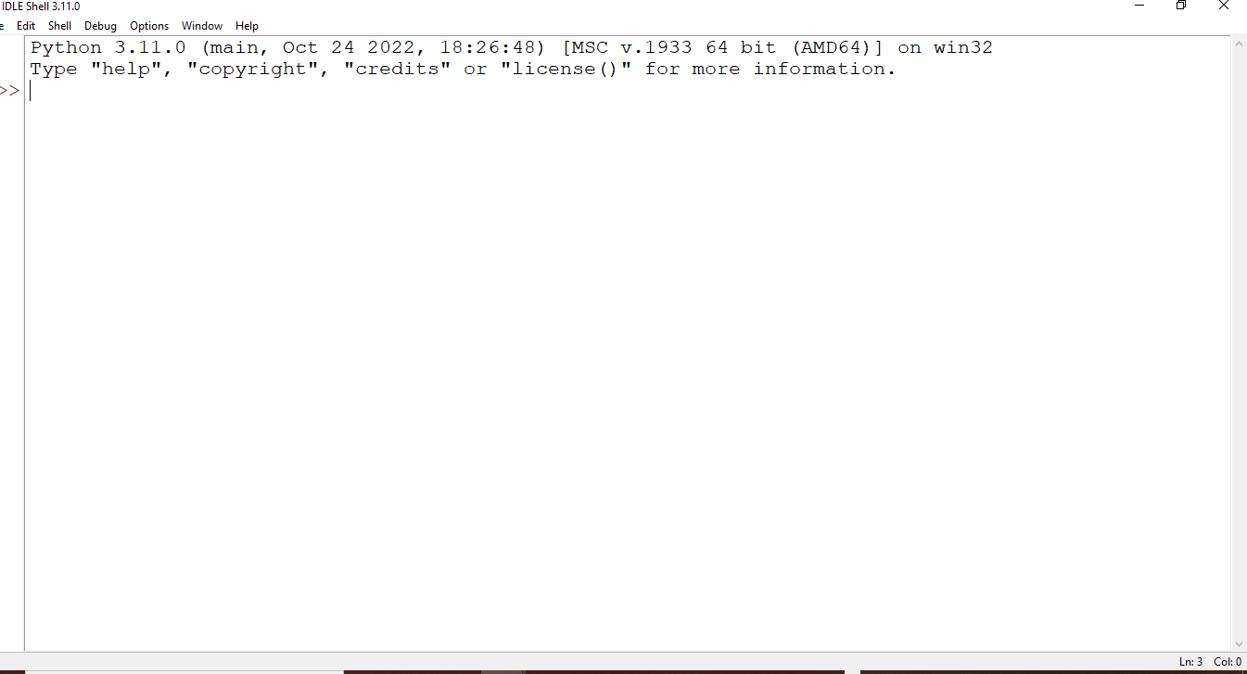

Step 5:

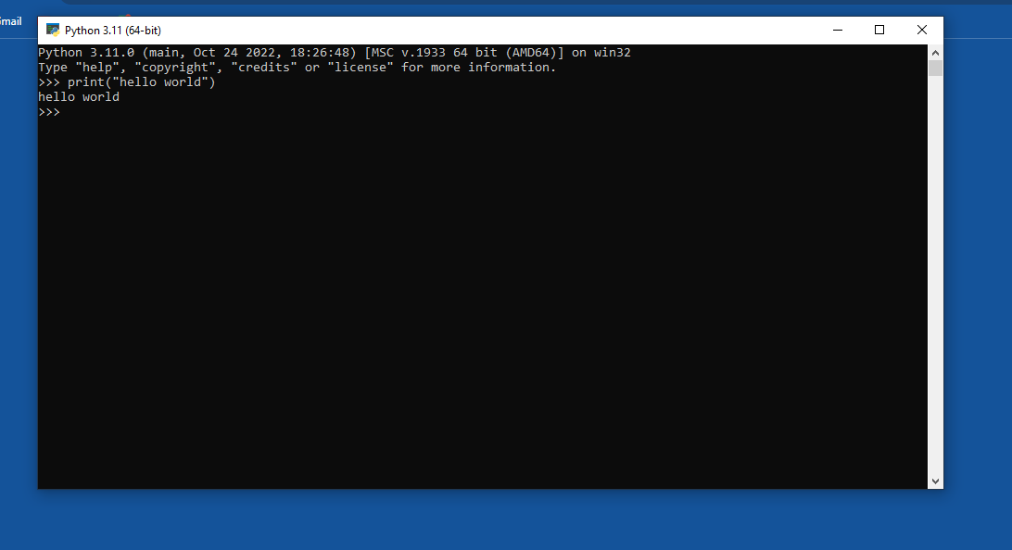

Step 6:

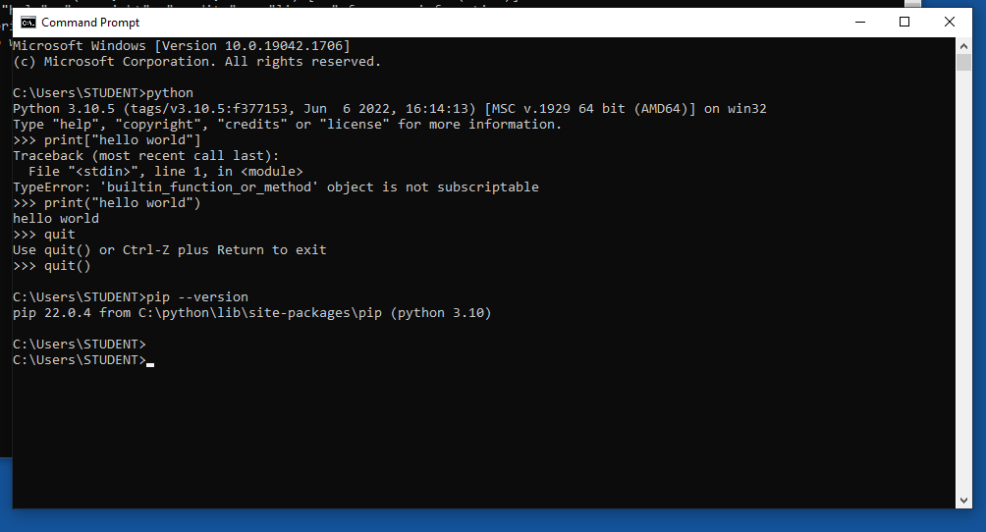

A python 3.9.8 is installed successfully.